Assessment Complex Game System Brief

Unity Networked Game: (Networked Inventory):

## Inventory Idea:

A Inventory system created to be able to pick up and drop objects without it duplicating said object and with objects being a open world object anyone can pick up not player specific but once picked up by one person no one else can pick up as they should be added to that players inventory.

* Moving objects in inventory:
* Shift click.
* Drag and drop.
* Hover and number allocation in Toolbelt/Hotbar.
* Double click.
* Trading with other players
* Press button on player.
* Chat command.
* On screen button.
* Ways to delete objects
* Drag object to a trash can in the inventory GUI
* Drag and drop object ..
* Keyboard button.
* Moving objects to and from inventory:
* Walking over object.
* Interacting with object.
* Drag and drop by clicking on object in a radius around you and moving it to inv.
* Inventory Storing / Layout
* Items can stack if stackable to a max amount set though inspector.
* Not all items will be stackable.

## Networked Game Inventory System:

### Purpose:

- The systems purpose will be to create an easy-to-use inventory system that’s customisable by the user. This customisation feature can be edited through unity’s inspector which will hold to a C# script that’s been created for the user. This can edit the amount of inventory spaces the inventory hold and the size of all the spaces for the items to be stored in.

system will create a easy way to control everything that will be store in the inventory. This script will be able to control the size and the number of items the inventory can store. All this information can be edited though the unity inspector.

### Integration:

- The basic GUI will all be done through C# scripting and linking to a unity UI interface.

## Unity Party Libraries:

|  |  |  |
| --- | --- | --- |
| Library | Licence | Version |
| Mirror | Extension Asset | 66.0.9 |
| Unity UI | Unity Companion Package License v1.0 | 1.0.0 |
| Unity Input System | Unity Companion Package License v1.0 | 1.0.2 |
| 2D Sprite | Unity Companion Package License v1.0 | 1.0.0 |
| Cinemachine | Unity Companion Package License v1.0 | 2.6.11 |
| Animation Rigging | Unity Companion Package License v1.0 | 1.0.3 |
| Universal RP | Unity Companion Package License v1.0 | 10.4.0 |
|  |  |  |

## Games with Similar Inventory Systems / layouts:

* Minecraft
* Ark Survival Evolved
* 7 Days to Die
* Grounded

## Game Inventory Layout Ideas from other Games:

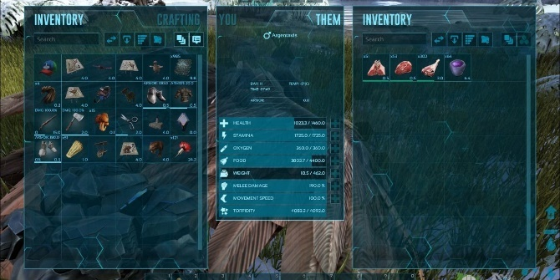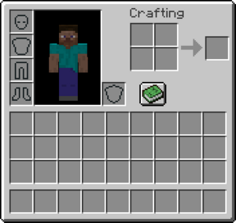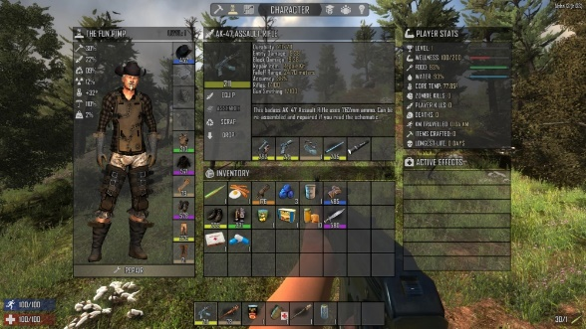

Game Mechanics

* So game object is linked to the 3d object and a 2D image
* Master list for all images and objects and in that the objects are linked to images
* How terraria handles its item system and how Minecraft handles its item and storage system look it up jesse said so
* Item in a stackable and not stackable categories stack value
* BASIC PATTENS OUTLINES co design data structure in aie canvas
* G
* Inv system
* Pick up object which share script object
* When object is picked it copys the sprip object to the inv and the slot